BURN SCAR CLASSIFICATION WITH SATELLITE IMAGES
USING DEEP CONVOLUTIONAL NEURAL NETWORK

Sasiprapa Thaewthatum
Geo-Informatics and Space Technology Development Agency (GISTDA)
120 The Government Complex Commemorating His Majesty the King’s 80th Birthday Anniversary 5th December,
B.E. 2550(2007), Chaengwattana Road, Lak Si, Bangkok 10210, THAILAND
e-mail: sasiprapa.t@gistda.or.th

KEY WORDS: Burn area classification, Deep Convolutional Neural Network (DCNN)

ABSTRACT: The comprehensive study on burn area classification with satellite images using Deep Convolutional Neural Network (DCNN) technique was presented. The primary objective was to enhance the efficiency and accuracy of burn area classification in Thailand. The DCNN is commonly used for identifying the patterns in images, particularly image classification. It can be applicable for a model of burn area classification using neural network architecture techniques. A novel GCN-BR-SegNet developed from SegNet was generated a model for burn area classification. In this study, a time series of Landsat-8 satellite images as input data was mainly used for burn area classification and the prior result was compared with the 2017 burned areas for validation. The result of the study indicated that the developed model was able to classify burned areas with the classification accuracy over 90%, particularly in mountainous and plain areas in northern and northeastern regions of Thailand. This can be applied for further burn area classification over the country with rapid processing.

1. INTRODUCTION
Wildfires in Thailand is recently critical issues for environmental impacts and people health. Since 2015 the traditional method of visual interpretation with a time series of satellite images was primary used for burn area classification in 9 provinces in northern part of Thailand. Even though the result showed more accurate classification, the technique was a long-time process and was not appropriate for large areas due to time-consuming. Burn scar detection with high frequency and accuracy over the country is a main challenge for planning and management; therefore, the advance technique using machine learning (ML) was necessary developed. This is because it allows computer systems to learn from data without being explicitly programmed and then to predict data with rapid processing (Bishop, 2006; Mohri, 2012).

2. OBJECTIVES
2.1 To develop a model for burn area classification with satellite images using Deep Convolutional Neural Network technique.
2.2 To compare burned areas derived from both visual classification and Deep Convolutional Neural Network technique.

3. DATA
3.1 A time series of Landsat-8 images in 2017
3.2 The 2017 burned areas from visual interpretation

4. METHODOLOGY
Firstly, the operating system program was installed for the model development on graphics processing unit. The Deep Learning library named Theano was installed and then applied for data training. The GCN-BR-SegNet was developed for generating a model of burn area classification. Secondly, a time series of Landsat-8 images was clipped a tile image with a size of 496*496 pixels and used as training data for feature extraction. A class of 0 and 1 was assigned as a type of non-burned and burned areas, respectively. Existing data of burned areas in 2017 was used as testing data in the developed model and was compared their results for validation. Additionally, the simple method of confusion matrix was then applied for checking the accuracy of image classification.

5. RESULTS AND DISCUSSION
Based on the model development of burn area classification using DCNN technique, a time series of Landsat-8 images was mainly used as training data and their results were compared with the 2017 burned areas derived from visual interpretation. The final results showed that the accuracy of the model can be divided into 2 main zones. Burned areas in mountainous zones as shown in Figure 1, the F1 score, the overall accuracy, and the Kappa coefficient were 64.71%, 94.19%, and 0.62, respectively (Table 1 and 2). Conversely, burned areas in plain zones as shown in Figure 2 found the F1 score, the overall accuracy, and the Kappa coefficient with 73.93%, 97.90%, and 0.73, respectively (Table 3 and 4).

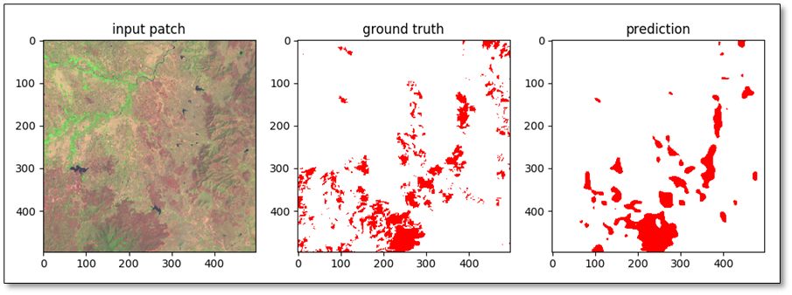
Figure 1. An example of burned areas in mountainous area, a tile image with a size of 496*496 pixels.

Table 1. Evaluation results of burn area classification based on DCNN technique model in mountainous areas.

 | Precision | Recall | F1
burned area | 0.746569 | 0.571016 | 0.647098
Non-burned areas | 0.956918 | 0.980062 | 0.968352
Average | 0.851744 | 0.775539 | 0.807725

Table 2. Results of burn area classification based on DCNN technique model in mountainous areas.
Burned areas (no. of pixels)
 | Burned area | Non-burned area | total
burned area | 112,231 | 38,098 | 150,329
Non-burned areas | 84,315 | 1,872,748 | 1,957,063
Total | 196,546 | 1,910,846 | 2,107,392
The overall accuracy was 94.19%; the Kappa Coefficient is 0.62

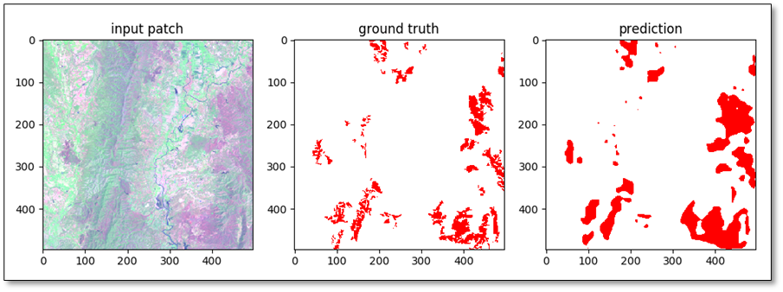
Figure 2. An example of burned areas in plain areas, a tile image with a size of 496*496 pixels.

Table 3. Evaluation results of burn area classification based on DCNN technique model in plain areas.

 | Precision | Recall | F1
burned area | 0.877615 | 0.638694 | 0.739332
Non-burned areas | 0.982537 | 0.995638 | 0.989044
Average | 0.930076 | 0.817166 | 0.864188

Table 4. Results of burn area classification based on DCNN technique model in plain areas.
Burned areas (no. of pixels)
 | Burned area | Non-burned area | total
burned area | 22,445 | 3,130 | 25,575
Non-burned areas | 12,697 | 714,368 | 727,065
Total | 35,142 | 717,498 | 752,640
The overall accuracy was 97.90%; the Kappa Coefficient was 0.73

Various techniques have been applied for image classification with high accuracy; however, there were some studies using deep learning techniques for burn area classification. The DCNN technique used in this study showed the better results of burned areas with quick process. It can be seen that the use of deep learning technique of DCNN was able for burn area classification, particularly in mountainous and plain areas of Thailand.

6. CONCLUSIONS
According to the study on burn area classification with multi-date Landsat-8 data using Deep Convolutional Neural Network, the result showed that this technique is crucial to enhance the efficiency of image classification with short-time processing and more accuracy. Even though the developed model provided the great results in 2 main zones (mountainous and plain areas), other areas are still needed an improvement of classification for further study.

7. RECOMMENDATIONS
Multi-date Landsat-8 satellite images were mainly used for classification in this study; therefore, other satellite images such as Sentinel-2A, 2B and Landsat-9 should be considered and used as training data for further study. Even though some burned areas in northern and northeastern regions showed high precise of classification, other burned areas, particularly burning in agricultural areas should be studied. According to a time limit, ground truth check is still required for improving the developed models and for validation.

8. REFERENCES
Audebert, N., Saux, B. and Lefèvre, S. (2017). Segment-before-Detect: Vehicle Detection and Classification through 477 Semantic Segmentation of Aerial Images. Remote Sens. 9, 368.
Bishop, C. M. (2006), Pattern Recognition and Machine Learning, Springer, ISBN0-387-31073-8
Gómez, I. and Martín, M., P. (2011). Prototyping an artificial neural network for burned area mapping on a regional scale in Mediterranean areas using MODIS images. International Journal of Applied Earth Observation and Geoinformation, 13, 741–752.
Kampffmeyer, M., Salberg, A. and Jenssen, R. (2016). Detection of Small Objects, Land Cover Mapping and Modelling of Uncertainty in Urban Remote Sensing Images Using Deep Convolutional Neural Networks. CVPR workshop
Petropoulos, G., P., Vadrevu, K., P., Xanthopoulos, G., Karantounias, G., and Scholze, M. (2010). Comparison of Spectral Angle Mapper and Artificial Neural Network Classifiers Combined with Landsat TM Imagery Analysis for Obtaining Burnt Area Mapping. Sensors, 10, 1967 – 1985.

